AM,C-Taino-Birds

Taino and BIRDS  
.  
  
Clay representation of a Taino owl (owl)  
By: Lynne Guitar, Ph.D. (History & Anthropology, Vanderbilt University, USA)  
  
Resident Manager, CIEE-Liberal Arts Program, PUCMM, Santiago de los Caballeros, Dominican Republic  
  
Member, Council of Elders / as, Foundation Guabancex Wind and Water  
  
DAY OF NATIVE PEOPLES, August 8, 2009  
  
Indigenous Caribbean chain probably sailed the Antillean islands to Kiskeya (Haiti, Bohio) following the route of migratory birds.  
  
The first to arrive (about 7 to 8.000 years ago) were hunter-fisher-gatherer years later came indigenous farmers. This and other Caribbean islands colonized had a green and lush flora. Birds brought most of the plants and trees that depended on the Indians. Birds eat the fruits and seeds of plants and trees that were in the mainland and other islands, bringing the seeds inside their bodies and leaving them in their droppings during their migratory flights.  
  
All kinds of birds and their eggs provided food in abundance for the Indians.  
  
Spanish chroniclers wrote that young men between the taíno kept iguacas (parakeets [¿cucas, coticas?]) As pets.  
  
The word Jajabi and / or Xaxabís probably indicated parakeets (Aratinga sp.), And Macaw, who was the Taíno name indicates in Spanish still the same bird, now defunct Island (Ara sp.).  
  
Young people were covered with leaves and iguacas accompanied by their pets, they climbed the nearby trees. Your pets shouted when younger sent. This attracted iguacas wild, and they have captured and killed for the pot of chili sauce, the ancestor of sancocho.  
  
Both females and young males between the Taino had a responsibility to protect conucos of birds. They protected them by throwing stones. Of course, if they killed some, also they threw the ajiaco.  
  
The Taino also ate birds roasted on a spit or baked-covered bodies of birds with clay and baked in hot ashes from their fires.  
  
The Spaniards complained that the Taino cooked whole birds, without first take away the feathers and entrails.  
  
Do the womb? Well, they are food. The Indians of the Americas almost never waste the food stuff.  
  
Taino pictograph two birds  
During migration season, when thousands of waterfowl resting in ponds, lakes and slow rivers, could capture hundreds of them at once. The Taino smoked meat in [ci] bucanes, made of green sticks, to preserve it for longer. The Taino also smoked in [ci] bucanes the hundreds of warblers (pigeons) that captured through networks pulling up trees where they were roosting. Several chroniclers wrote that the warblers taíno attracted by the perfect imitation of their songs.  
  
The Taino developed a technique to capture waterfowl Spanish described as "gracious," and perhaps it was. What they did was bring and silently surround the part of the lagoon, pond or lake where birds were resting and eating .... And suddenly they threw Higüeros water. The birds, well frightened, flew noisily. They circulating, could see that the fig trees were harmless, so they got off the water again. Now hunters big and empty Higüeros put over their heads-with holes that could see and breathe - and carefully entered the water up to his neck, so that only Higüeros be seen. They moved their heads to mimic the movement of the fig trees floating in the water. In his hands, hidden underwater, each hunter had a knapsack. Approaching one of the waterfowl, the hunter took a Halon by its legs so that the other thought that plunged to eat something ... and put it in his knapsack, where he drowned in silence. In this way hunters could move in the water and fill their knapsacks ... and the bellies of their families.  
  
But the birds to the Taino had more value than simply serving as a pet or protein. The iguacas, for example, had a commercial value and often regaled.  
  
Christopher Columbus wrote in his diary that all Indians who was in "The Indies" iguacas offered him with great respect.  
  
The taíno decorated the top of the crowns of their kacikes cotton with brightly colored feathers. They used pens to "embroider" intricate and beautiful designs used in the decoration of both crowns and ceremonial cloaks of kacikes, as naguas cotton married nitaínas and strips of cotton they all wore on his forearms and the calves of his legs.  
  
Many males as females decorative feathers added color to the chains that were on ceremonial occasions. Some of the archaic accounts that have been found have drilled holes in two directions, one for the cord and one for the feathers.  
  
The birds had other practical uses for taíno. The usual mores, particularly migratory birds, attended the taíno to maintain its annual calendar.  
.  
  
Taino pictograph of a flamingo

And there are some species that never fly away from Earth, so they could guide the fishermen and / or traders plying the high seas during the day.  
  
Even small changes in the habits of birds-customs that taíno knew intimately because they and their ancestors had lived here for thousands of years-they could alert them to the ferocious hurakanes who could enter gallantly and cause widespread destruction. It served to this earwig, because "you can see flying in the breeze fronts and indicating weather changes" (Wikipedia).  
  
After 1492, changes in the habits of birds could also indicate the imminent arrival of Spanish ships and patrols.  
  
Another taíno myth that preserved Pané speaks of the day when [the] inriri [Chauvial] (woodpecker) helped early humans on the island to create again women after Guaguyona, the first bejike, he went with all original . They caught a slippery and genderless creatures found playing in some trees a rainy day, using the Caracaracol (men with a skin disease that became very rough, scaly hands).

They tied the creatures and put some inriri so they could peck where the genitals of women are.  
  
In another myth about Guaguyona (the first bejike), he sent a man by the name of Yadruvava to find an herb called I say that people wiped his body. Yadruvava came before dawn, but Güey, sun, caught on the way and changed into a bird "singing in the morning, like a nightingale. The bird is called Yahuba Bayael ".  
  
We report the Taino Tribe Jatibonuco (Boriken), old stories that once upon a time the hummingbird flies were transformed Papa Sol (Güey).  
  
William Keegan and Betsy Carlson ( "Talking Taíno: Birds of a Feather") believe that the Taino associated hummingbird with rainbow by "the crescent shape of the body and its iridescent hummingbird feathers ..."  
  
"The rainbow forms a bridge that connects the earth, the sky, and the world of groundwater: the three domains of taíno cosmos. Animals that move freely between these domains are much "believed, they write.  
  
The smallest hummingbird, the bee hummingbird, was called by the Taino Guani, a word that indicates the nobility. (Before they were found in all the islands of the Greater Antilles, but today only exists in Cuba and Middle Caicos.)  
  
In addition to Guani and Hummingbird, other Tainos names for hummingbird Zum-Zum apparently were, Guacariga and Guaracacigaba. The Tribe of Jatibonuco P.R. They say that the last two names mean "Rays of the Sun" in Taino.  
  
We do not know all the Taíno names for birds living in Kiskeya-but there is a record of 50.  
  
Taino pictograph bird interacting  
Bejikes and BIRDS  
  
The bejikes had many important roles: doctor, priest, diplomat, mediator androgynous gender, clans, tribes, nations and populations centers-and among the most powerful of the Cemis of the Taino. One of the main responsibilities of a bejike was directing funerals and rituals to honor the Cemis (the spirits of the dead), rituals directed mainly inside the caves.  
  
The most powerful ally of the bejikes was Maquetaurie Guava, the Lord of the Dead and the Kacike of Coaybay, the divine world of the Taino.  
  
Guava Maquetaurie symbol is the owl (Owl) -múcaro means "Night Eagle".  
  
It is a bird with vision so acute at night, I could see right into the divine world.  
  
It is by this that the owl was a symbol of death and life after death for the Taino, and still remains so today in most of the region of the Greater Antilles - if an owl hoots near his home, is message bad news-the Dominican tradition says that indicates that a family member will die soon.  
  
Pictographs of bejikes in caves represent the myths and legends ancient, sacred rites and ceremonies cojoba, the Cemis who controlled the breeze, rain, sun and hurakanes, and grocery dependent people, including many representations of birds in all categories.  
  
Birds on branches  
  
Do they represent the pictographs of the domain Pomier Caves birds that have the highest of the three levels taíno cosmos?  
  
Many experts think so.  
  
So perhaps they represent the kacikes among the Taino, who were the highest of power between them, as some experts have also suggested.  
  
Some believe that the pictograph of five birds sitting on a branch (which was painted on a wall of the Cave Pomier no. 1), represents the five kacikazgos when the island was divided when the Spanish arrived in 1492, or the five supreme kacikes .  
  
The behiques also painted birds representing humans in some "signs" that indicate how to traverse the difficult tunnels into some of the sacred caves.  
  
Perhaps the birds represent humans because both vertically walk?  
  
Pictographs birds are in many of the caves throughout the island. In some birds they represent humans, in others only ... birds.  
  
Do most about deeper meanings? The truth is that very little is known about the meanings of the pictographs, petroglyphs and other symbols of the indigenous Taino or that preceded them. We can only make informed guesses.  
  
Images Taínas Bird  
  
The cosmos of the Taino was three levels: water, earth and sky. For them, the birds were sacred because they could "easily cross between heaven and earth".  
  
Waterfowl were sacred because they could cross between water, earth and sky. (Keegan and Carlson).  
  
Apparently taíno waterbirds associated with Coatrisquie, one of the assistants Guabancex, the cemí (androgynous) of hurricanes. Coatrisquie and Guatauba gathered the waters came to earth in a destructive manner. Keegan and Carlson suggest that the Taino Pelican images represent Coatrisquie.  
  
It is obvious that birds will influence much to the Taino - his grace, his skills as hunters, in the form of care with dedication to their babies, the communal nature of some (like the palms ciguas), and of course his songs.  
  
Communal celebrations among areitos were called Taino, a word that means "song" in Taino.  
Areito or areyto (plural areitos) was a ceremony associated with ancestor worship performed by the [Taíno](http://archaeology.about.com/od/tterms/g/taino.htm) people of the Caribbean. These important ceremonies involved dances and music and played an important role in Taíno social, political, and religious live.

Areitos usually took place in the main plaza of a village or in the area in front of the chief’s house. These areas worked as dance grounds and were limited by an earthen embankment or by a series of standing stones, often decorated with carved images of [zemis](http://archaeology.about.com/od/zterms/a/Zemis.htm), mythological beings or noble ancestors.

The purpose of areito ceremonies was for the living to communicate with the spirit world. This was attained through music, dances and reaching ecstatic states through hallucinogenic substances. Areitos took place on many different occasions, to celebrate birth, marriages or mourn death, to declare war or peace, or to celebrate the arrival or departure of important visitors.

The first Europeans to meet the Taínos described these ceremonies in many instances.

Areito or areyto (plural areitos) was a ceremony associated with ancestor worship performed by the [Taíno](http://archaeology.about.com/od/tterms/g/taino.htm) people of the Caribbean. These important ceremonies involved dances and music and played an important role in Taíno social, political, and religious live.

Areitos usually took place in the main plaza of a village or in the area in front of the chief’s house. These areas worked as dance grounds and were limited by an earthen embankment or by a series of standing stones, often decorated with carved images of [zemis](http://archaeology.about.com/od/zterms/a/Zemis.htm), mythological beings or noble ancestors.

The purpose of areito ceremonies was for the living to communicate with the spirit world. This was attained through music, dances and reaching ecstatic states through hallucinogenic substances. Areitos took place on many different occasions, to celebrate birth, marriages or mourn death, to declare war or peace, or to celebrate the arrival or departure of important visitors.

The first Europeans to meet the Taínos described these ceremonies in many instances.

The ceremonial plaza of [Caguana](http://archaeology.about.com/od/caterms/a/Caguana.htm), one of the most important Taino settlements in Puerto Rico, was one of the preferred settings for such events.

Caribbean archaeologists and historian also propose that throughout Caribbean prehistory, areyto ceremonies changed meaning, becoming more and more a form of veneration and prestige acquisition for the different local leaders (caciques), and their families and less a form of ancestor worship.

### Sources

This glossary entry is a part of the About.com guide to [Caribbean](http://archaeology.about.com/od/northamerica/a/Caribbean-Archaeology.htm), and the [Dictionary of Archaeology](http://archaeology.about.com/od/glossary/Archaeology_Dictionary_Index.htm).

Atkinson, Lesley-Gail (ed.), 2006, The Earliest Inhabitants. The Dynamics of the Jamaican Taíno. University of West Indies press

Saunders Nicholas J., 2005, The Peoples of the Caribbean. An Encyclopedia of Archaeology and Traditional Culture. ABC-CLIO, Santa Barbara, California.

Wilson, Samuel, 2007, The Archaeology of the Caribbean, Cambridge World Archaeology Series. Cambridge University Press, New York.

**The melodic songs of human beings, which certainly were influenced by the singing of birds, were extremely important for taíno. They were so important that there was no better gift that a human being could give a song to another, even to give to a kacike.  
  
The music and singing still an integral part of the daily lives of Dominicans and all your celebrations.  
  
Music and song, a cheerful heritage that comes from high-¡de the Taino and birds!**  
  
******  
BETWEEN THE PRESENCE OF MONKEYS TAINOS  
.  
  
Saimiri monkey, ape-like fossil found in Kiskeya  
By: RENATO O. RIMOLI  
  
Foundation Guabancex Wind And Water, Day of Indigenous Peoples, Autonomous University of Santo Domingo, Pedro Mir Library, August 11, 2009.  
Endemic Caribbean Monkeys  
  
Monkey genus Ateles (Spider Monkey)  
  
The monkeys of this genus are characterized by having a prehensile tail. Remains of a specimen of this kind was found in a burial cave in Sancti Spiritus, Cuba, in 1911.  
  
Howler Monkey Alouatta genus  
  
In Cuba they described two extinct species of the genus corresponding howler monkeys Paralouatta, very close to the continental howler monkey Alouatta genus. The howl is due to thickening of the neck by modifying the hyoid bone in the form of a soundboard.  
  
Remains of Jamaican Jamaican Monkey monkey species mcgregori  
  
This specimen corresponds to a cranial fragment with the maxillary molars and their respective series. It is the only known primate species endemic to the island of Jamaica.

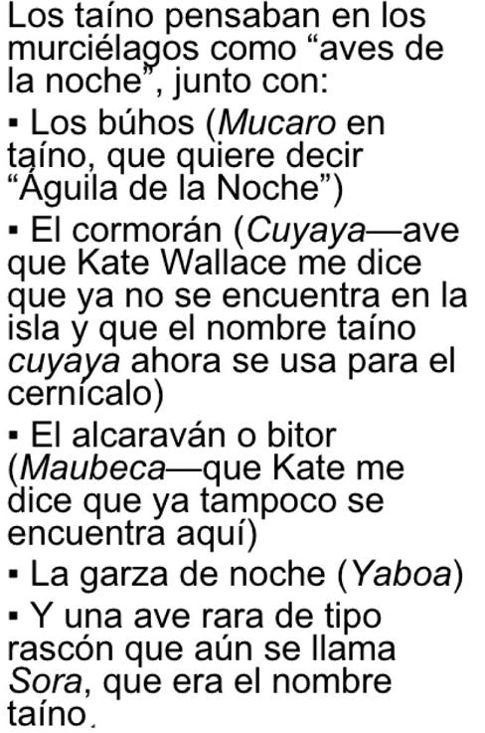

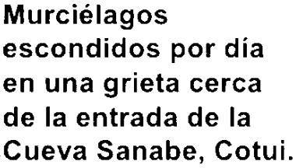

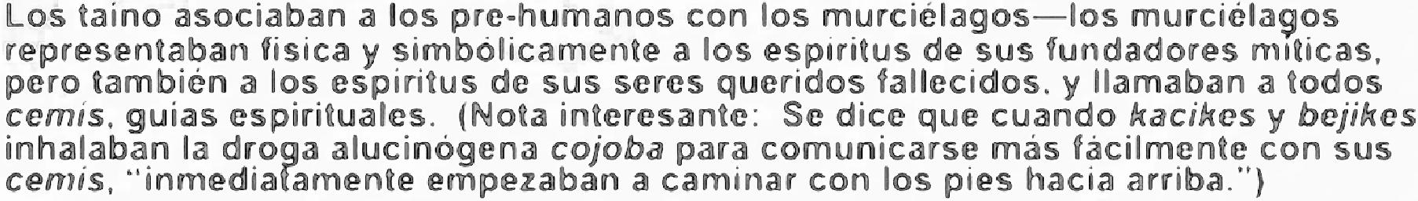

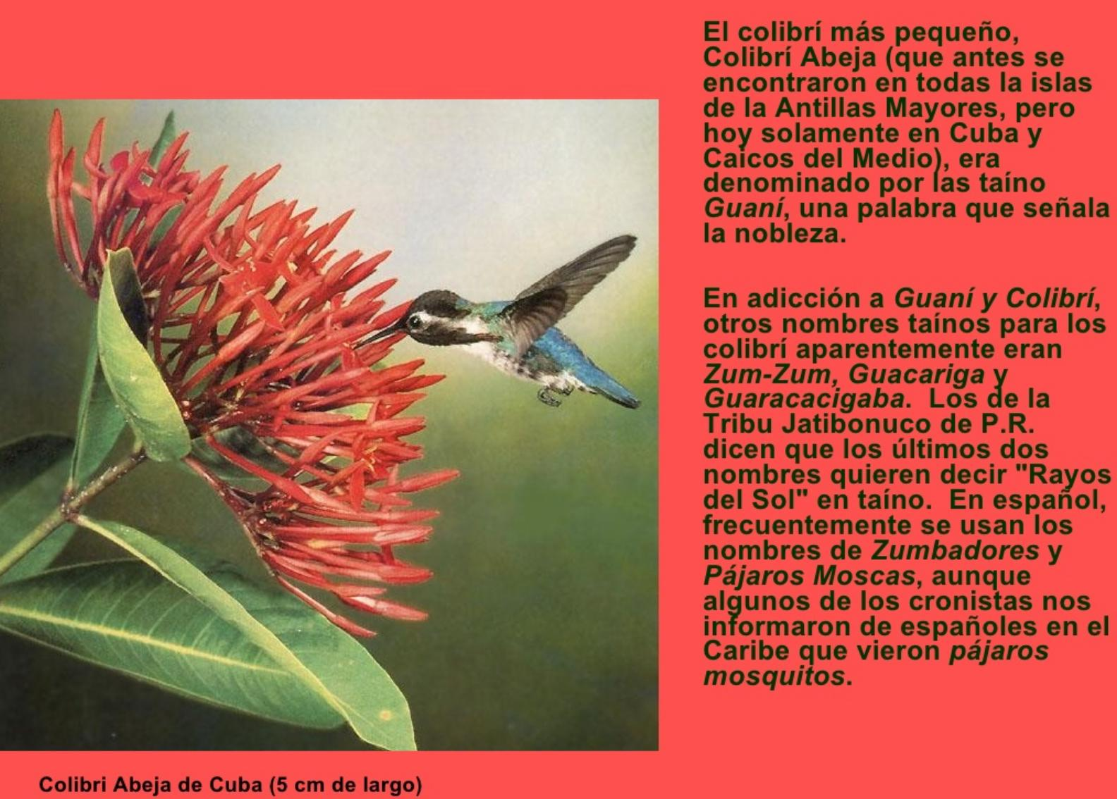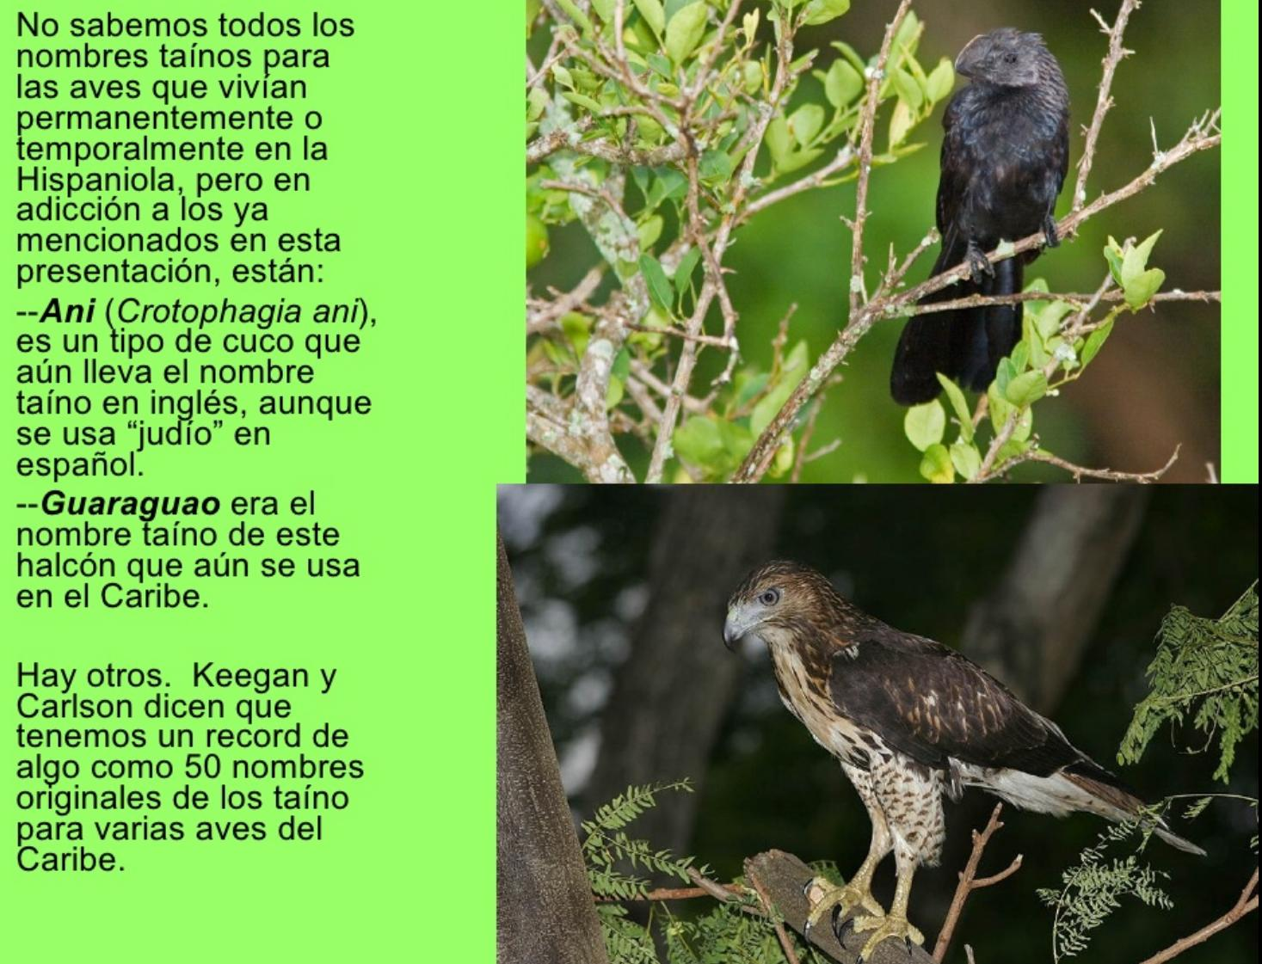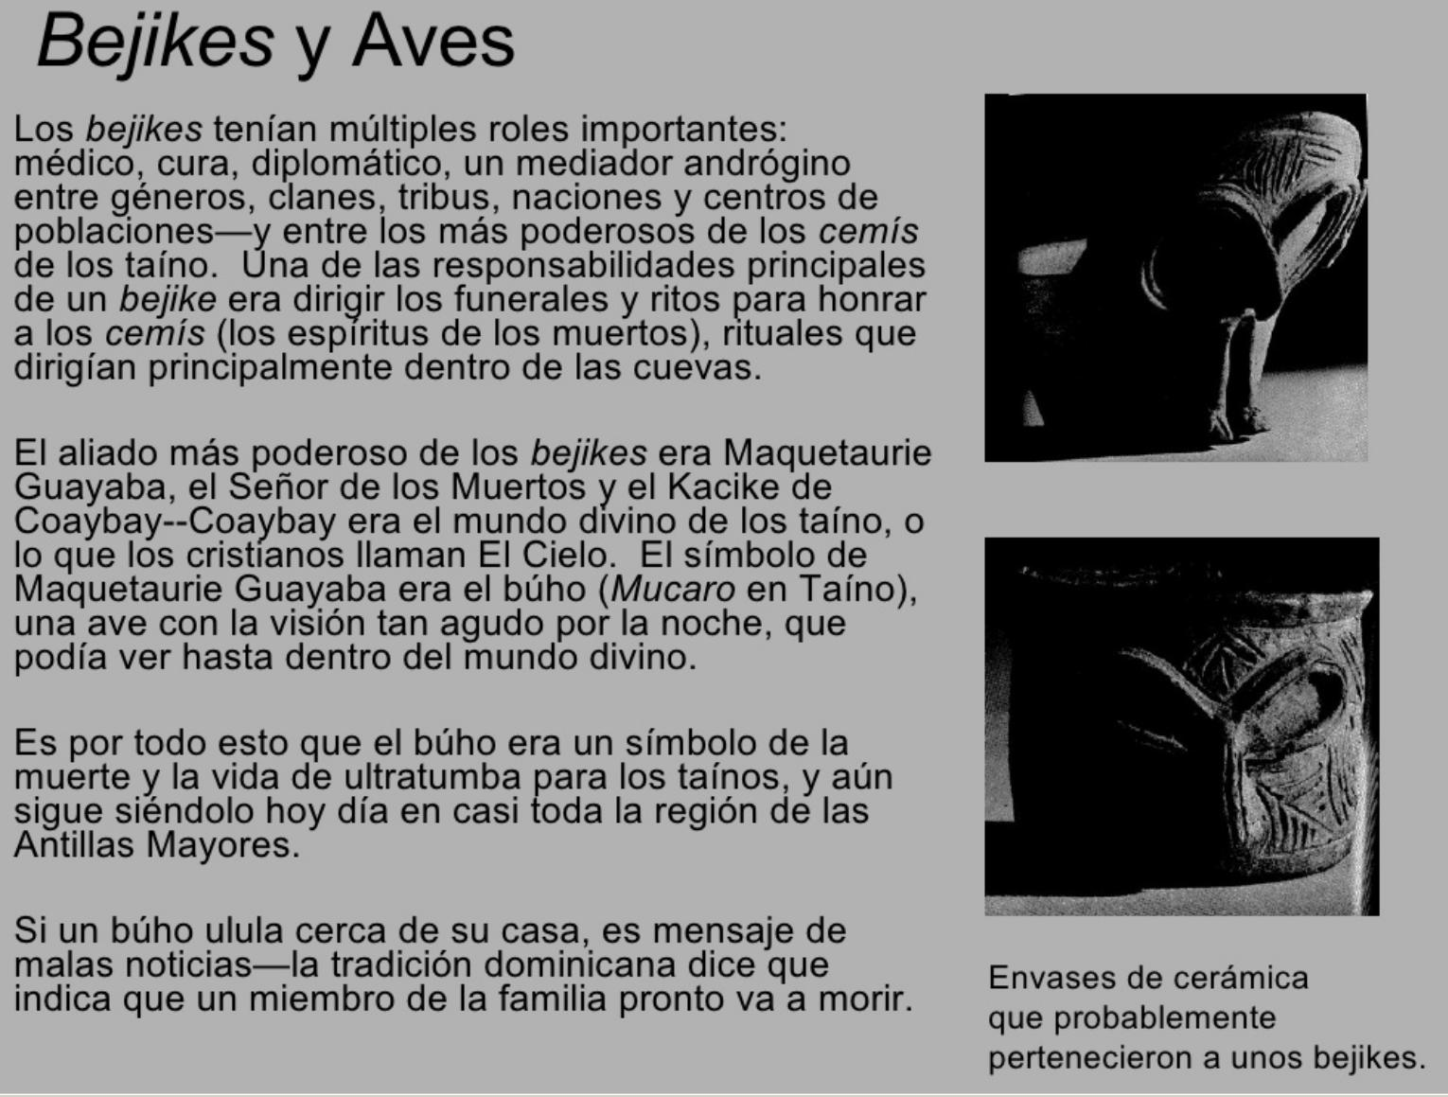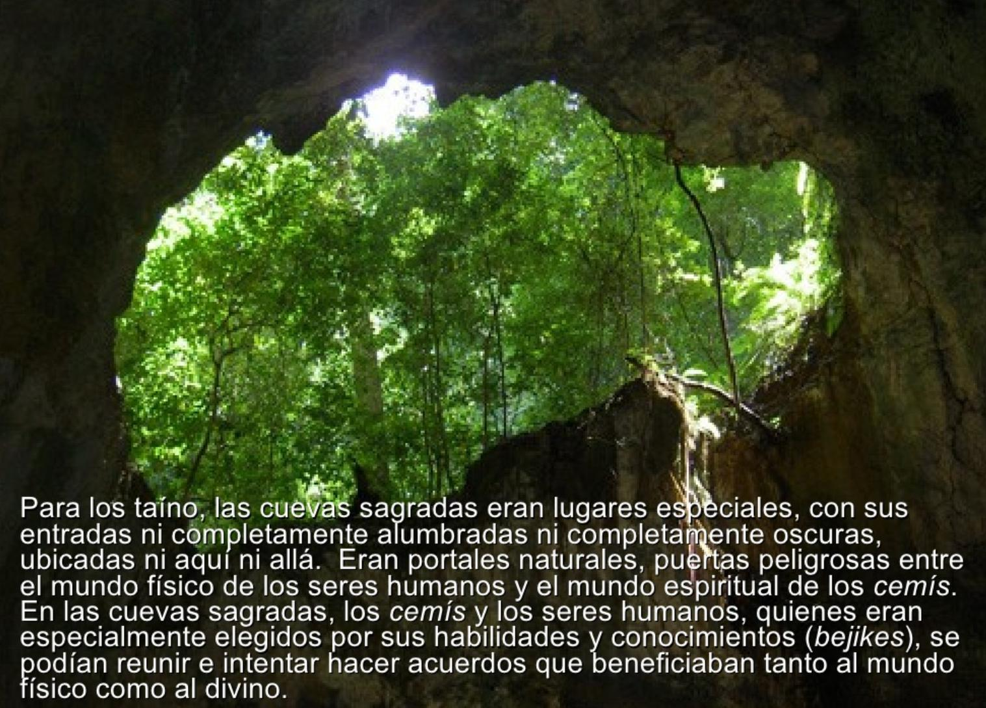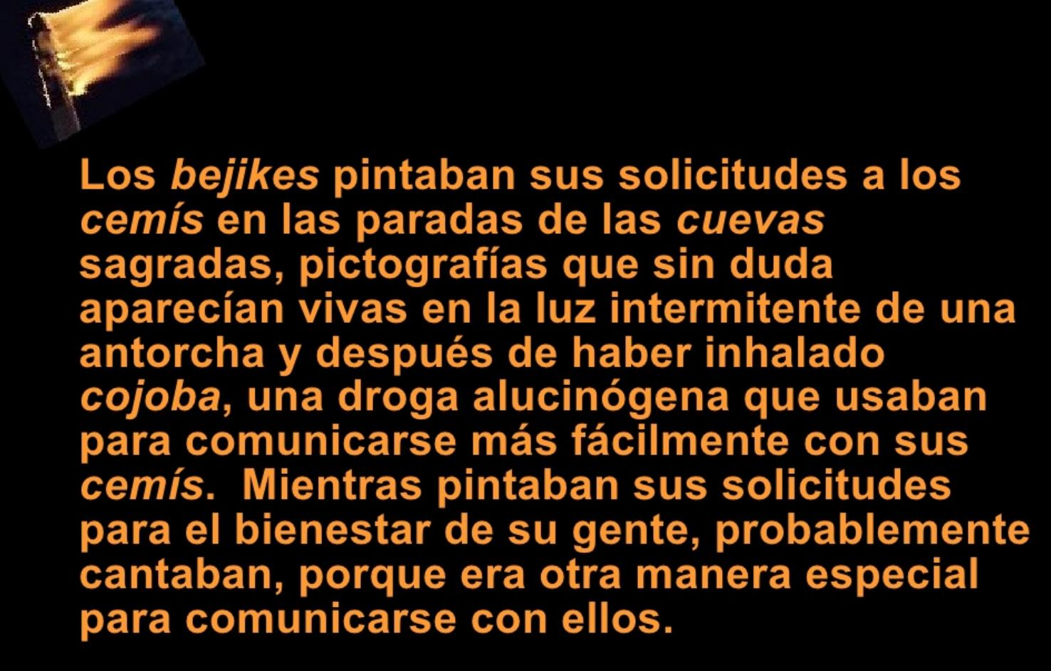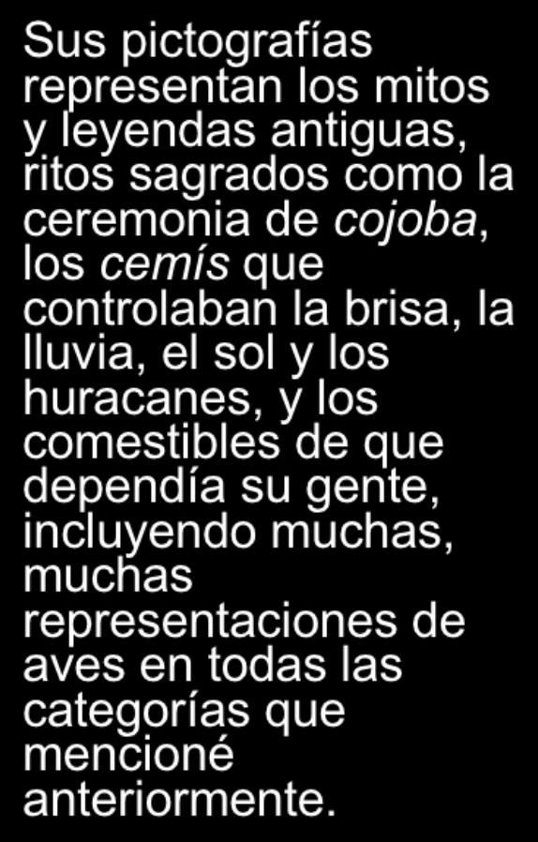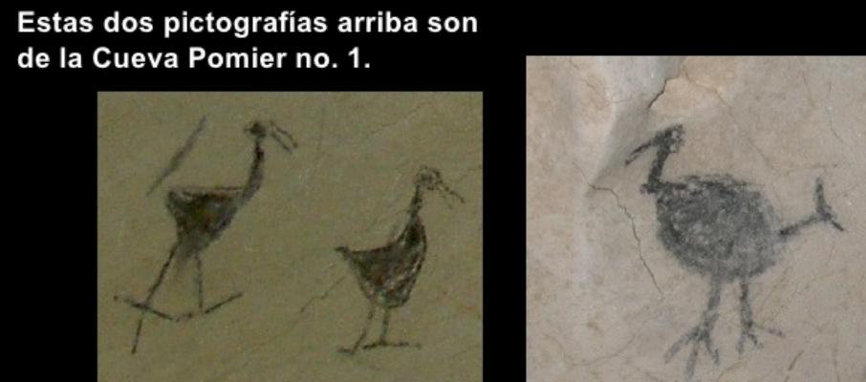

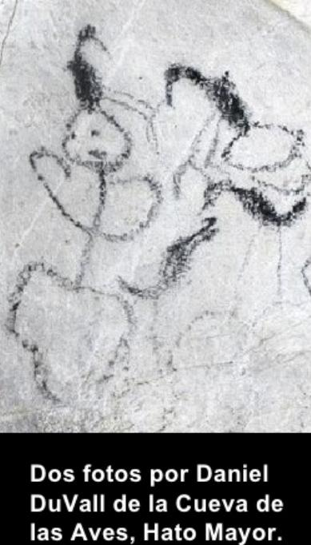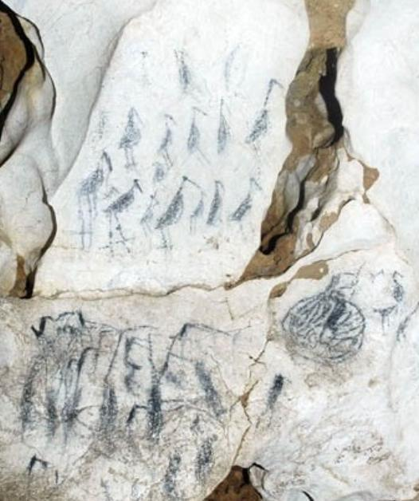

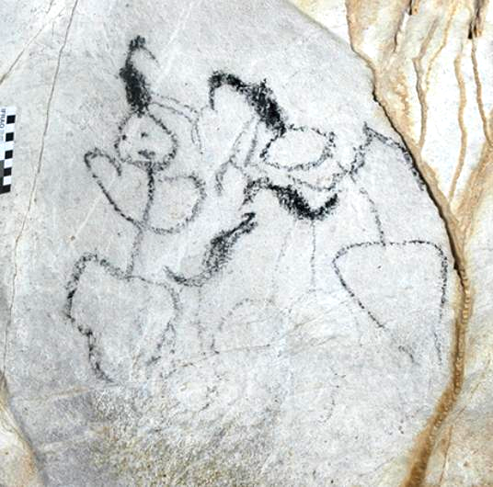

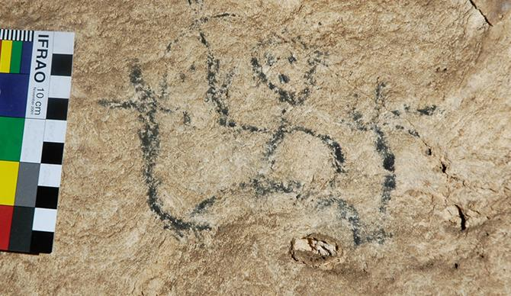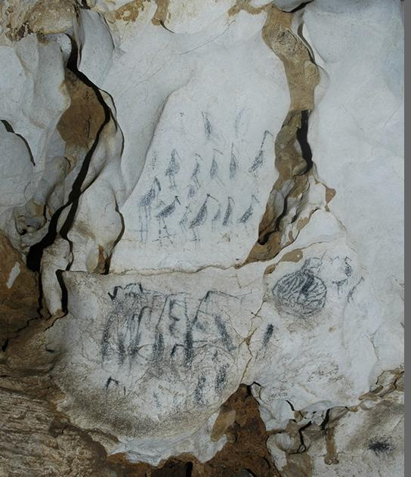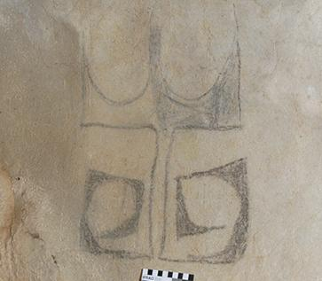

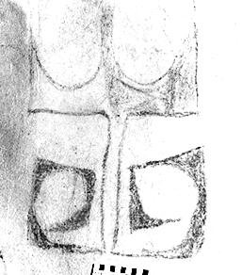 double crown!

